<LOST AND FIND PORTAL>

**Design Document**

**Version 1.0**

**Group Id: S25PROJECT0D77C**

**Supervisor Name: Sir. Muhammad Salman Bashir**

**Revision History**

|  |  |  |  |
| --- | --- | --- | --- |
| **Date (dd/mm/yyyy)** | **Version** | **Description** | **Author** |
| 20/07/2025 | 1.0 | This design document provides detailed descriptions and diagrams, including ERD, sequence diagrams, architecture design, class diagrams, database design, interface design, and test cases, to serve as a comprehensive blueprint for developing the Online lost and find portal. | Bc220409231 |
|  |  |  |  |
|  |  |  |  |
|  |  |  |  |

**Table of Content**

TASK#1 5

**Introduction of Design Document**:- 5

TASK#2 10

**Entity Relationship Diagram (ERD)** 10

TASK#3 11

**Sequence Diagrams:-** 11

**1)** **User Registration:-** 11

**2)** **Login:-** 12

**3)** **Search & Filter Items:-** 13

13

**4)** **Post Lost & Find Items:-** 14

14

**5)** **Messaging Between Users:-** 15

**6)** **Reminders:-** 16

7) **Admin Manage Items:-** 17

8) **Admin Manage Users:-** 18

**9)** **Logout:-** 19

TASK#4 20

**Architecture Design Diagram:-** 20

TASK#5 21

**Class Diagram:-** 21

TASK#6 22

**Database Design** 22

TASK#7 23

**Interface Designs-** 23

**HomePage:-** 23

**User Register:-** 24

**User Login:-** 25

**How To Use:-** 26

TASK#8 :- 26

**Test Cases** 26

Register Account 26

Login 27

Logout 27

Post Lost Item 27

Post Found Item 28

Search Items 28

Filter Items 28

View Item Details 29

Send Message to Post Owner 29

View Received Messages 29

Admin Login 30

View All Users 30

Delete User 30

View All Posts 30

Delete/Moderate Post 31

Review Messages 31

Test Case - 14 - Logout 31

# TASK#1

## **Introduction of Design Document**:-

This design document outlines the detailed design and architecture of the Online Community Item Exchange System. It includes essential diagrams and descriptions that provide a comprehensive understanding of the system's structure and behavior. The primary purpose of this document is to serve as a blueprint for the development team, ensuring that all aspects of the system are well-documented and clearly defined.

1. **Entity Relationship Diagram (ERD)**

* **Entities**: Represent objects or concepts, such as that have data stored about them.
* **Relationships:** Illustrate how entities are connected
* **Attributes:**  Characteristics or properties of entities, such as User_ID for Users or item_id, title, genre etc.

This diagram provides a visual representation of the data model, illustrating the relationships between different entities within the system. This diagram is crucial for understanding how data is structured and interconnected.

1. **Sequence Diagrams:**

* **Objects:** Instances of classes that interact in the system.
* **Messages:** Communications between objects, shown as arrows.
* **Lifelines:** Represent the existence of an object over time.
* **Activation:** Represented by a thin rectangle or a tall, thin box, this shows when a participant is actively performing an action or operation.
* **Deactivation:** Represented by a small circle or a short, thin rectangle, this shows when a participant's action or operation is complete.
* **Conditions:** Represented by a diamond or a rectangle with a decision icon, these show the conditions or logic that govern the interactions.
* **Alternative paths:** Represented by a diamond or a rectangle with multiple outgoing arrows, these show alternative scenarios or branches.

Sequence diagrams are provided for each use case, detailing the interactions between objects over time. These diagrams help in visualizing the flow of tasks within the system and are essential for understanding the dynamic behavior of the system.

1. **Architecture Design Diagram:**

* **Layers:** Different levels of the system, such as presentation, business logic, and data access layers.
* **Components:** Functional units within each layer, like User Interface, and Database.
* **Interactions:** How layers and components communicate with each other.

The architecture design diagram presents a tiered architecture of the system, highlighting the different layers and their interactions. This section is important for understanding the overall structure and deployment of the system.

1. **Class Diagram:**

* **Classes:** Blueprints for objects, defining attributes and methods, like User, Admin.
* **Relationships:** Connections between classes, such as inheritance (Admin inherits from User), association, aggregation, and composition.
* **Attributes and Methods:** Characteristics and behaviors defined within each class. The class diagram provides a static view of the system, showing the system classes, their attributes, methods, and relationships. This diagram is fundamental for object-oriented design and development.
* **Inheritance:** Represented by an arrow pointing from a subclass to a super class, this shows the inheritance relationship between classes.
* **Composition:** Represented by a filled diamond at the end of a line connecting classes, this shows the whole-part relationship between classes.
* **Association:** Represented by a line connecting classes, this shows the relationship between classes, such as a student enrolling in a course.
* **Multiplicity:** Represented by numbers or symbols at the ends of a line connecting classes, this shows the cardinality of the relationship, such as one-to-one or many-to-many.
* **Dependencies:** Represented by a dashed arrow pointing from a dependent class to an independent class, this shows the dependency relationship between classes.
* **Interfaces:** Represented by a circle or a rectangle with a name, these define a contract or a set of operations that a class must implement.

1. %3CmxGraphModel%3E%3Croot%3E%3CmxCell%20id%3D%220%22%2F%3E%3CmxCell%20id%3D%221%22%20parent%3D%220%22%2F%3E%3CUserObject%20label%3D%22%22%20tags%3D%22Background%22%20id%3D%222%22%3E%3CmxCell%20style%3D%22vsdxID%3D1%3BfillColor%3Dnone%3BgradientColor%3Dnone%3BstrokeColor%3Dnone%3Bpoints%3D%5B%5B1%2C0.5%2C0%5D%2C%5B0.5%2C0.5%2C0%5D%2C%5B0.5%2C0%2C0%5D%5D%3BlabelBackgroundColor%3Dnone%3Brounded%3D0%3Bhtml%3D1%3BwhiteSpace%3Dwrap%3B%22%20vertex%3D%221%22%20parent%3D%221%22%3E%3CmxGeometry%20x%3D%22838%22%20y%3D%2234%22%20width%3D%22254%22%20height%3D%22401%22%20as%3D%22geometry%22%2F%3E%3C%2FmxCell%3E%3C%2FUserObject%3E%3CmxCell%20id%3D%223%22%20style%3D%22vsdxID%3D2%3BfillColor%3D%23ffffff%3BgradientColor%3Dnone%3Bshape%3Dstencil(rZBLDoAgDERP0z3SI%2Fi5B4kojQgE8Xd7IY3RuHY303lt0gGsF6OCBimWFP2kd%2BqTAWxASnJGR0pZAbaA9eCjHqNfXc8%2BqEIWNfutXDh4T5QNKU52lWDfMWrJvdA7%2FB%2F%2BC83i%2BXMga7mmd%2F7tJY%2B4U2wv)%3BstrokeColor%3D%23ffffff%3Bpoints%3D%5B%5B0%2C0.5%2C0%5D%2C%5B1%2C0.5%2C0%5D%2C%5B0.5%2C1%2C0%5D%2C%5B0.5%2C0%2C0%5D%5D%3BlabelBackgroundColor%3Dnone%3Brounded%3D0%3Bhtml%3D1%3BwhiteSpace%3Dwrap%3B%22%20vertex%3D%221%22%20parent%3D%222%22%3E%3CmxGeometry%20width%3D%22254%22%20height%3D%221%22%20as%3D%22geometry%22%2F%3E%3C%2FmxCell%3E%3CmxCell%20id%3D%224%22%20style%3D%22vsdxID%3D3%3BfillColor%3D%23d8d8d8%3BgradientColor%3Dnone%3Bshape%3Dstencil(nZBLDoAgDERP0z3SIyjew0SURgSD%2BLu9kMZoXLhwN9O%2BtukAlrNpJg1SzDH4QW%2FURgNYgZTkjA4UkwJUgGXng%2B6DX1zLfmoymdXo17xh5zmRJ6Q42BWCfc2oJfdAr%2BYv%2BAP9Cb7OJ3H%2F2JG1HNGz%2F84klThPVCc%3D)%3BstrokeColor%3D%23ffffff%3Bpoints%3D%5B%5B0%2C0.5%2C0%5D%2C%5B1%2C0.5%2C0%5D%2C%5B0.5%2C1%2C0%5D%2C%5B0.5%2C0%2C0%5D%5D%3BlabelBackgroundColor%3Dnone%3Brounded%3D0%3Bhtml%3D1%3BwhiteSpace%3Dwrap%3B%22%20vertex%3D%221%22%20parent%3D%222%22%3E%3CmxGeometry%20width%3D%22254%22%20height%3D%22401%22%20as%3D%22geometry%22%2F%3E%3C%2FmxCell%3E%3CmxCell%20id%3D%225%22%20value%3D%22%22%20style%3D%22vsdxID%3D4%3BedgeStyle%3Dnone%3Bdashed%3D1%3BdashPattern%3D2.00%202.00%3BstartArrow%3Dnone%3BendArrow%3Dnone%3BstartSize%3D5%3BendSize%3D5%3BstrokeColor%3D%23115582%3BspacingTop%3D0%3BspacingBottom%3D0%3BspacingLeft%3D0%3BspacingRight%3D0%3BverticalAlign%3Dmiddle%3Bhtml%3D1%3BlabelBackgroundC

%22600%22%20as%3D%22sourcePoint%22%2F%3E%3CmxPoint%20x%3D%22740%22%20y%3D%22550%22%20as%3D%22targetPoint%22%2F%3E%3C%2FmxGeometry%3E%3C%2FmxCell%3E%3CmxCell%20id%3D%22176%22%20value%3D%22%22%20style%3D%22endArrow%3Dnone%3Bhtml%3D1%3Brounded%3D0%3BexitX%3D0.063%3BexitY%3D0.994%3BexitDx%3D0%3BexitDy%3D0%3BexitPerimeter%3D0%3B%22%20edge%3D%221%22%20source%3D%2215%22%20parent%3D%221%22%3E%3CmxGeometry%20width%3D%2250%22%20height%3D%2250%22%20relative%3D%221%22%20as%3D%22geometry%22%3E%3CmxPoint%20x%3D%22650%22%20y%3D%22600%22%20as%3D%22sourcePoint%22%2F%3E%3CmxPoint%20x%3D%221537%22%20y%3D%22547%22%20as%3D%22targetPoint%22%2F%3E%3C%2FmxGeometry%3E%3C%2FmxCell%3E%3CmxCell%20id%3D%22177%22%20value%3D%22%22%20style%3D%22endArrow%3Dnone%3Bhtml%3D1%3Brounded%3D0%3B%22%20edge%3D%221%22%20parent%3D%221%22%3E%3CmxGeometry%20width%3D%2250%22%20height%3D%2250%22%20relative%3D%221%22%20as%3D%22geometry%22%3E%3CmxPoint%20x%3D%221491%22%20y%3D%22140%22%20as%3D%22sourcePoint%22%2F%3E%3CmxPoint%20x%3D%221716%22%20y%3D%22140%22%20as%3D%22targetPoint%22%2F%3E%3C%2FmxGeometry%3E%3C%2FmxCell%3E%3CmxCell%20id%3D%22178%22%20value%3D%22%22%20style%3D%22endArrow%3Dnone%3Bhtml%3D1%3Brounded%3D0%3BexitX%3D0.97%3BexitY%3D0.138%3BexitDx%3D0%3BexitDy%3D0%3BexitPerimeter%3D0%3B%22%20edge%3D%221%22%20source%3D%22143%22%20parent%3D%221%22%3E%3CmxGeometry%20width%3D%2250%22%20height%3D%2250%22%20relative%3D%221%22%20as%3D%22geometry%22%3E%3CmxPoint%20x%3D%221590%22%20y%3D%22640%22%20as%3D%22sourcePoint%22%2F%3E%3CmxPoint%20x%3D%221650%22%20y%3D%22640%22%20as%3D%22targetPoint%22%2F%3E%3C%2FmxGeometry%3E%3C%2FmxCell%3E%3CmxCell%20id%3D%22179%22%20value%3D%22%22%20style%3D%22endArrow%3Dnone%3Bhtml%3D1%3Brounded%3D0%3BentryX%3D0.597%3BentryY%3D1.023%3BentryDx%3D0%3BentryDy%3D0%3BentryPerimeter%3D0%3B%22%20edge%3D%221%22%20source%3D%2228%22%20target%3D%22133%22%20parent%3D%221%22%3E%3CmxGeometry%20width%3D%2250%22%20height%3D%2250%22%20relative%3D%221%22%20as%3D%22geometry%22%3E%3CmxPoint%20x%3D%22900%22%20y%3D%22480%22%20as%3D%22sourcePoint%22%2F%3E%3CmxPoint%20x%3D%22950%22%20y%3D%22430%22%20as%3D%22targetPoint%22%2F%3E%3C%2FmxGeometry%3E%3C%2FmxCell%3E%3CmxCell%20id%3D%22180%22%20value%3D%22%22%20style%3D%22endArrow%3Dnone%3Bhtml%3D1%3Brounded%3D0%3BentryX%3D0.106%3BentryY%3D0.991%3BentryDx%3D0%3BentryDy%3D0%3BentryPerimeter%3D0%3B%22%20edge%3D%221%22%20target%3D%228%22%20parent%3D%221%22%3E%3CmxGeometry%20width%3D%2250%22%20height%3D%2250%22%20relative%3D%221%22%20as%3D%22geometry%22%3E%3CmxPoint%20x%3D%221030%22%20y%3D%221110%22%20as%3D%22sourcePoint%22%2F%3E%3CmxPoint%20x%3D%221080%22%20y%3D%221060%22%20as%3D%22targetPoint%22%2F%3E%3C%2FmxGeometry%3E%3C%2FmxCell%3E%3CmxCell%20id%3D%22181%22%20value%3D%22%22%20style%3D%22endArrow%3Dnone%3Bhtml%3D1%3Brounded%3D0%3BexitX%3D0.5%3BexitY%3D0%3BexitDx%3D0%3BexitDy%3D0%3BexitPerimeter%3D0%3B%22%20edge%3D%221%22%20source%3D%2247%22%20parent%3D%221%22%3E%3CmxGeometry%20width%3D%2250%22%20height%3D%2250%22%20relative%3D%221%22%20as%3D%22geometry%22%3E%3CmxPoint%20x%3D%221839%22%20y%3D%221134%22%20as%3D%22sourcePoint%22%2F%3E%3CmxPoint%20x%3D%221825.69%22%20y%3D%22839%22%20as%3D%22targetPoint%22%2F%3E%3C%2FmxGeometry%3E%3C%2FmxCell%3E%3CmxCell%20id%3D%22182%22%20value%3D%22%22%20style%3D%22endArrow%3Dnone%3Bhtml%3D1%3Brounded%3D0%3BentryX%3D0.991%3BentryY%3D0.865%3BentryDx%3D0%3BentryDy%3D0%3BentryPerimeter%3D0%3B%22%20edge%3D%221%22%20target%3D%2233%22%20parent%3D%221%22%3E%3CmxGeometry%20width%3D%2250%22%20height%3D%2250%22%20relative%3D%221%22%20as%3D%22geometry%22%3E%3CmxPoint%20x%3D%221715%22%20y%3D%221136%22%20as%3D%22sourcePoint%22%2F%3E%3CmxPoint%20x%3D%221720%22%20y%3D%221060%22%20as%3D%22targetPoint%22%2F%3E%3C%2FmxGeometry%3E%3C%2FmxCell%3E%3CmxCell%20id%3D%22183%22%20value%3D%22%22%20style%3D%22endArrow%3Dnone%3Bhtml%3D1%3Brounded%3D0%3BentryX%3D0.022%3BentryY%3D0.958%3BentryDx%3D0%3BentryDy%3D0%3BentryPerimeter%3D0%3BexitX%3D0.007%3BexitY%3D0.205%3BexitDx%3D0%3BexitDy%3D0%3BexitPerimeter%3D0%3B%22%20edge%3D%221%22%20source%3D%2242%22%20target%3D%22133%22%20parent%3D%221%22%3E%3CmxGeometry%20width%3D%2250%22%20height%3D%2250%22%20relative%3D%221%22%20as%3D%22geometry%22%3E%3CmxPoint%20x%3D%22883%22%20y%3D%221098%22%20as%3D%22sourcePoint%22%2F%3E%3CmxPoint%20x%3D%22720%22%20y%3D%22630%22%20as%3D%22targetPoint%22%2F%3E%3C%2FmxGeometry%3E%3C%2FmxCell%3E%3CmxCell%20id%3D%22184%22%20value%3D%22%22%20style%3D%22endArrow%3Dnone%3Bhtml%3D1%3Brounded%3D0%3BentryX%3D0.28%3BentryY%3D0.987%3BentryDx%3D0%3BentryDy%3D0%3BentryPerimeter%3D0%3B%22%20edge%3D%221%22%20source%3D%2233%22%20parent%3D%221%22%3E%3CmxGeometry%20width%3D%2250%22%20height%3D%2250%22%20relative%3D%221%22%20as%3D%22geometry%22%3E%3CmxPoint%20x%3D%221378%22%20y%3D%221100%22%20as%3D%22sourcePoint%22%2F%3E%3CmxPoint%20x%3D%221651%22%20y%3D%22749%22%20as%3D%22targetPoint%22%2F%3E%3C%2FmxGeometry%3E%3C%2FmxCell%3E%3CmxCell%20id%3D%22185%22%20value%3D%22%22%20style%3D%22endArrow%3Dnone%3Bhtml%3D1%3Brounded%3D0%3BexitX%3D0.97%3BexitY%3D-0.009%3BexitDx%3D0%3BexitDy%3D0%3BexitPerimeter%3D0%3BentryX%3D0.01%3BentryY%3D-0.008%3BentryDx%3D0%3BentryDy%3D0%3BentryPerimeter%3D0%3B%22%20edge%3D%221%22%20source%3D%2238%22%20target%3D%22153%22%20parent%3D%221%22%3E%3CmxGeometry%20width%3D%2250%22%20height%3D%2250%22%20relative%3D%221%22%20as%3D%22geometry%22%3E%3CmxPoint%20x%3D%22596%22%20y%3D%22968%22%20as%3D%22sourcePoint%22%2F%3E%3CmxPoint%20x%3D%221262%22%20y%3D%22850%22%20as%3D%22targetPoint%22%2F%3E%3C%2FmxGeometry%3E%3C%2FmxCell%3E%3CmxCell%20id%3D%22186%22%20value%3D%22%22%20style%3D%22endArrow%3Dnone%3Bhtml%3D1%3Brounded%3D0%3BentryX%3D0.014%3BentryY%3D0.819%3BentryDx%3D0%3BentryDy%3D0%3BentryPerimeter%3D0%3B%22%20edge%3D%221%22%20target%3D%22101%22%20parent%3D%221%22%3E%3CmxGeometry%20width%3D%2250%22%20height%3D%2250%22%20relative%3D%221%22%20as%3D%22geometry%22%3E%3CmxPoint%20x%3D%221134%22%20y%3D%22683%22%20as%3D%22sourcePoint%22%2F%3E%3CmxPoint%20x%3D%221262%22%20y%3D%22683%22%20as%3D%22targetPoint%22%2F%3E%3C%2FmxGeometry%3E%3C%2FmxCell%3E

1. **Database Design:**

* **Tables:** Structures that store data, corresponding to entities in the ERD.
* **Columns:** Fields within tables, representing attributes.
* **Relationships:** Connections between tables, implemented via foreign keys. The database design section includes diagrams that detail the schema of the database, ensuring that the data is organized efficiently and supports the application's requirements.

1. **Interface Design:**

* **Screenshots:** Visual representations of the user interface.
* **Layouts:** Arrangement of elements on the screen.
* **User Interactions:** How users interact with the interface.
* **Accessibility:** A description of the accessibility features and considerations, including WCAG guidelines and screen reader support.
* **Responsive Design:** A description of the responsive design approach, including breakpoints, layouts, and media queries.
* **Design Rationale:** A explanation of the design decisions, including the reasoning behind the design choices.

This section provides screenshots of the system's graphical user interface (GUI). It show cases the main interfaces, demonstrating the application's most important features and how users will interact with the system.

**8. Test Cases:**

* **Test Scenarios:** Specific situations to be tested.
* **Test Steps:** Detailed actions to perform the test.
* **Expected Results:** Anticipated outcomes of the test.

Test cases for each use case scenario are provided to ensure that the system's functionality is thoroughly tested. This section is vital for validating the system against its requirements and ensuring its reliability.

**Benefits and Purpose of the Design Phase:**

The design phase in a software development project is critical for several reasons:

* **Clarity and Communication:** It provides a clear and shared understanding of the system among all stakeholders, including developers, designers, and clients.
* **Blueprint for Development:** It serves as a detailed blueprint that guides the development process, ensuring that all components are developed in a coherent and consistent manner.
* **Risk Mitigation:** By defining the system architecture and design early potential issues can be identified and addressed before implementation begins, reducing risks and avoiding costly changes later.
* **Quality Assurance:** Detailed design documentation supports rigorous testing and validation, helping to ensure that the final product meets the specified requirements and standards.
* **Scalability and Maintenance:** A well-thought-out design facilitates future scalability and ease of maintenance, allowing the system to evolve with changing requirements.

This document is instrumental in ensuring the successful development and deployment of the Online lost and find portal, providing a solid foundation for building a robust, efficient, and user-friendly application.

# TASK#2

## **Entity Relationship Diagram (ERD)**

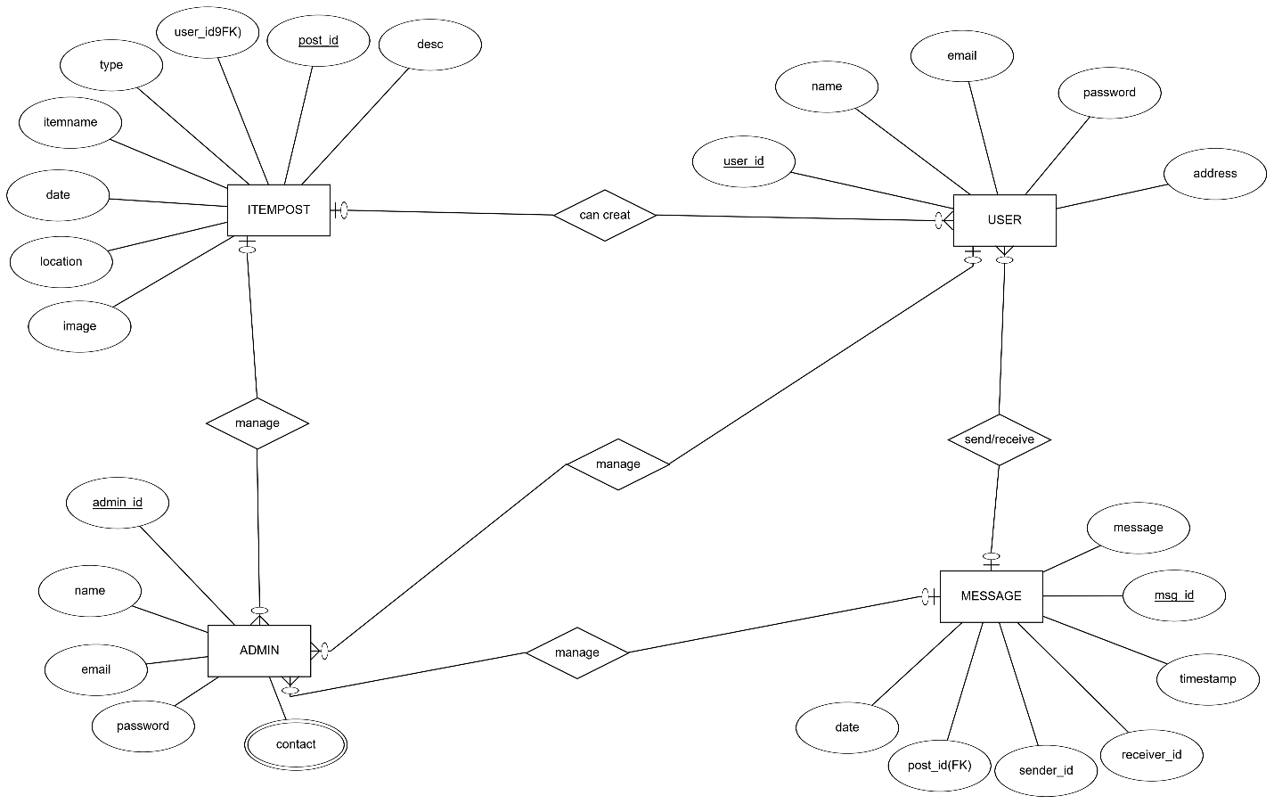

**Diagram 1**

# TASK#3

## **Sequence Diagrams****:-**

1. **User Registration:-**

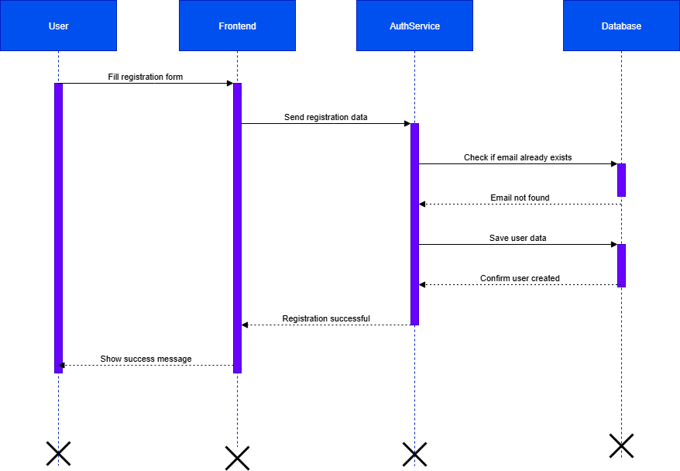

**Diagram 2**

1. **Login:-**

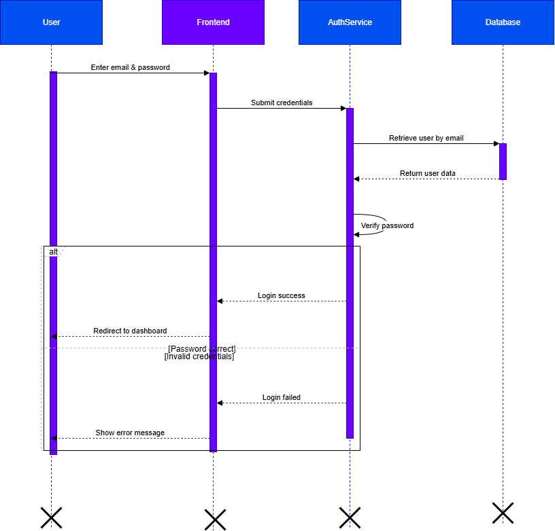

**Diagram 3**

1. **Search & Filter Items:-**

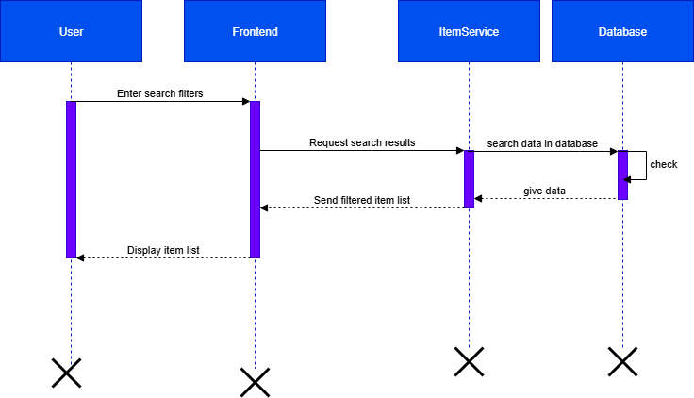

**Diagram 4**

1. **Post Lost & Find Items:-**

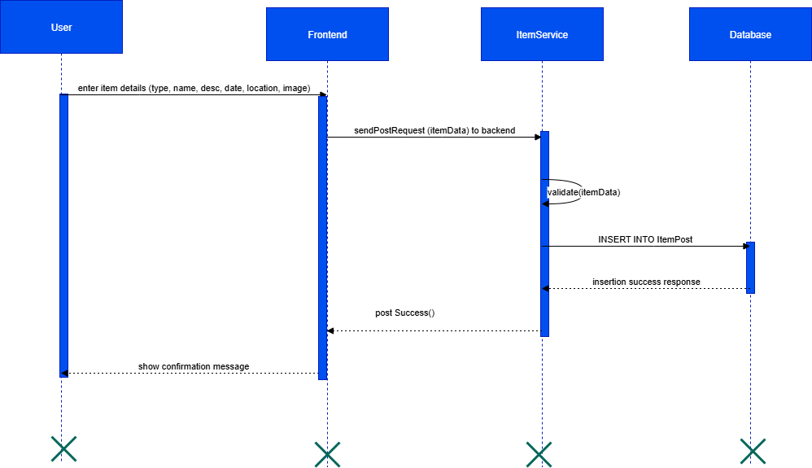

**Diagram 5**

1. **Messaging Between Users:-**

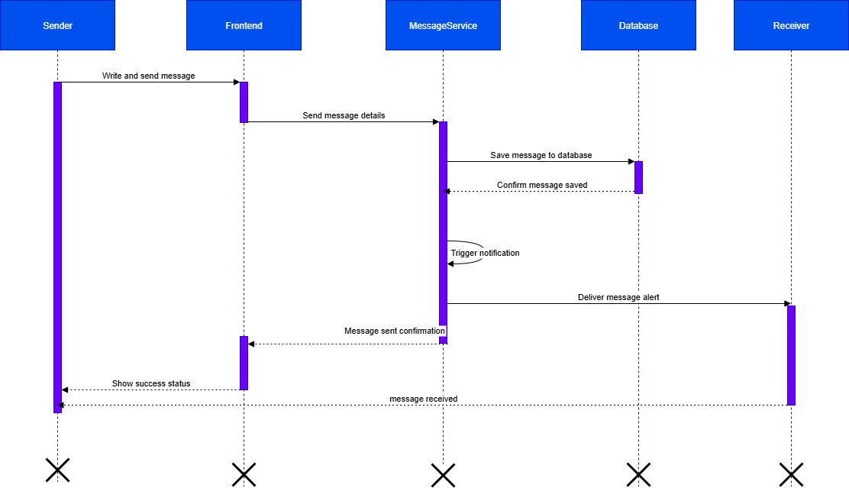

**Diagram 6**

1. **Reminders:-**

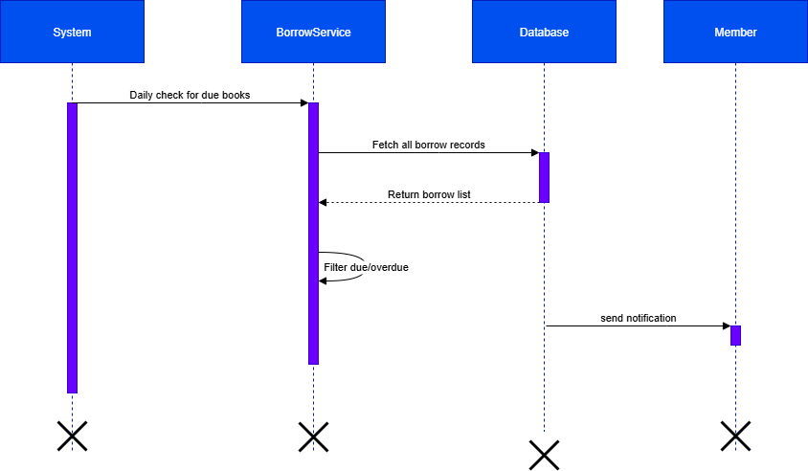

**Diagram 7**

1. **Admin Manage Items:-**

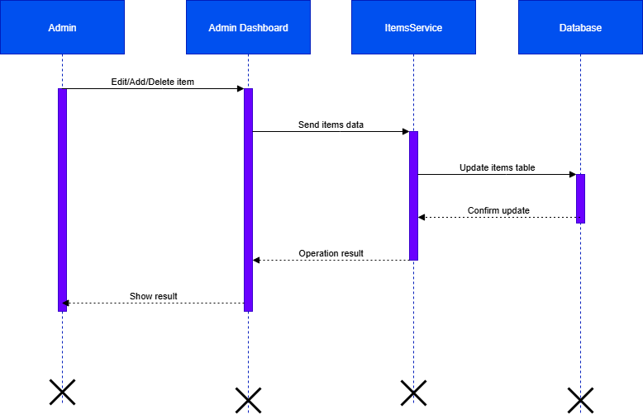

**Diagram 8**

1. **Admin Manage Users:-**

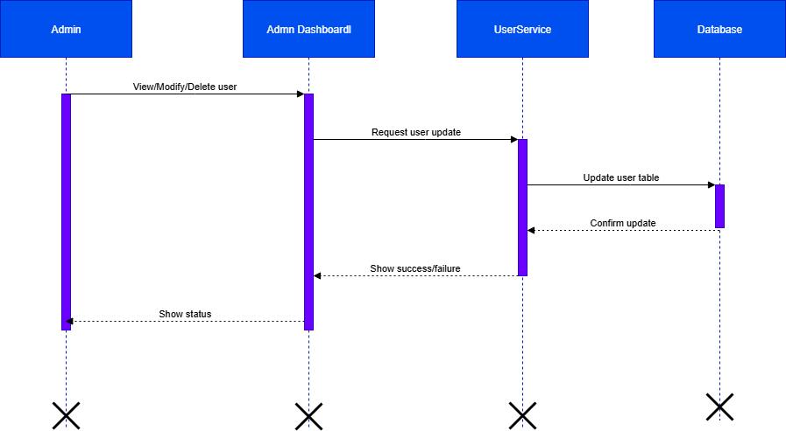

**Diagram 09**

1. **Logout:-**

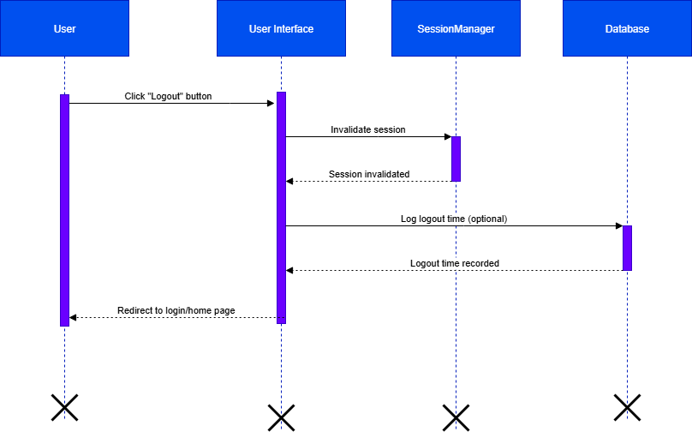

**Diagram 10**

# TASK#4

## **Architecture Design Diagram:-**

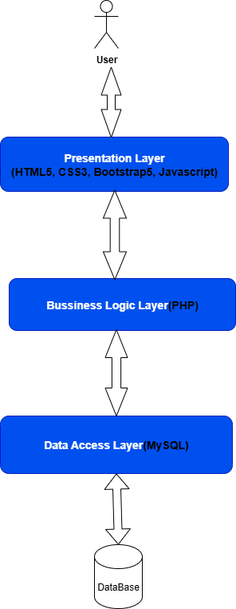

**Diagram 14**

# TASK#5

## **Class Diagram:-**

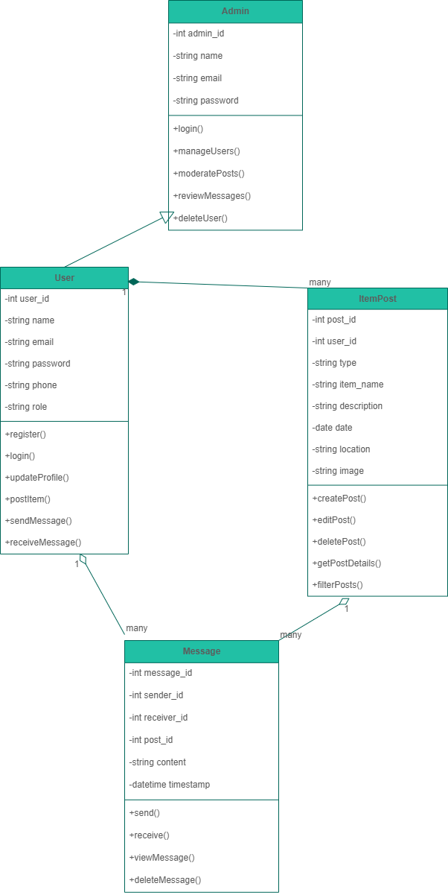

**Diagram 15**

# TASK#6

### **Database Design**

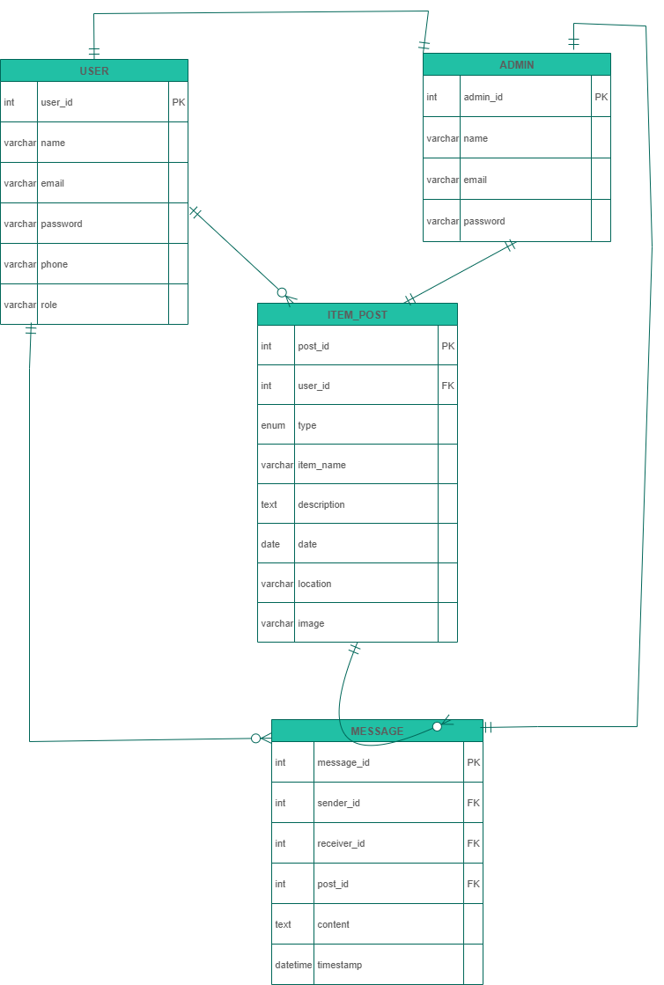

**Diagram 16**

# TASK#7

## **Interface Designs-**

### **HomePage:-**

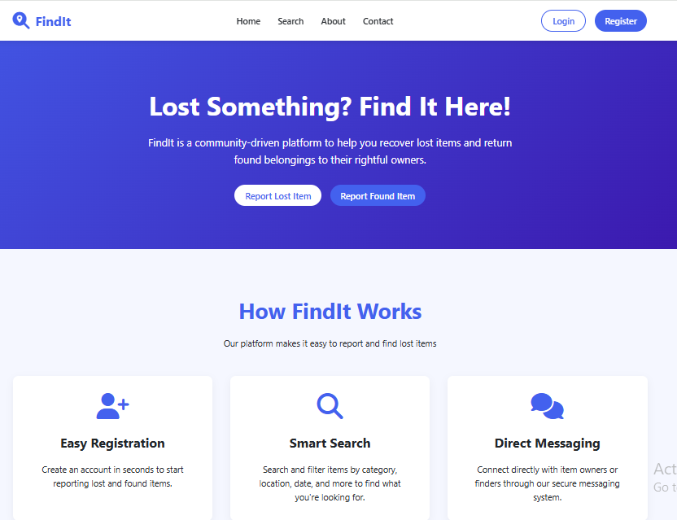

### **User Register:-**

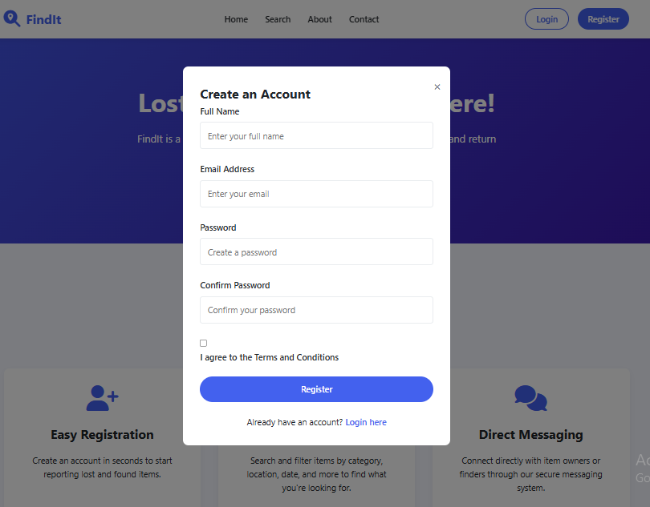

### **User Login:-**

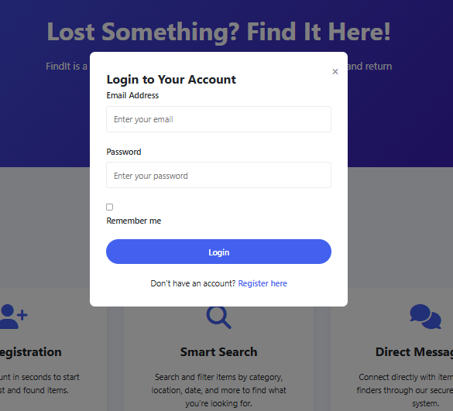

### **How To Use:-**

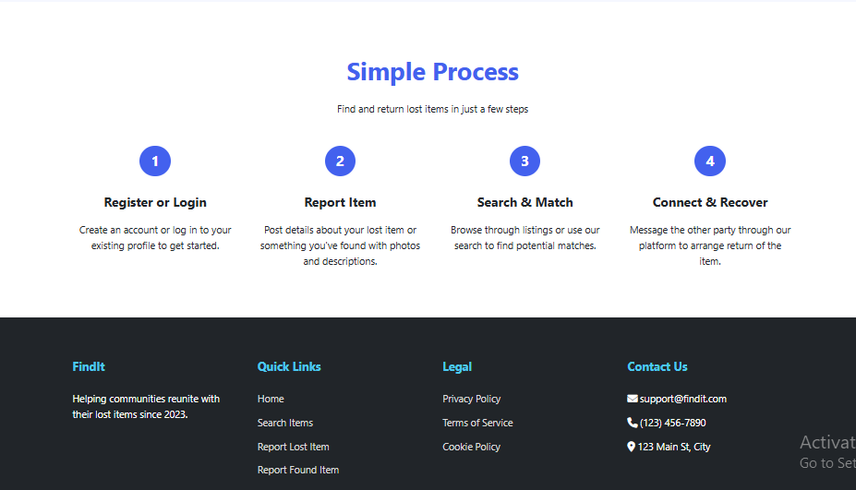

# TASK#8 :-

## **Test Cases**

## Register Account

|  |  |
| --- | --- |
| Test Case ID | TC_U01 |
| Test Case Title | Register Account |
| Purpose | Verify the function of: register account |
| Steps | 1. Launch system 2. Navigate to page 3. Provide necessary input 4. Submit 5. Validate response |
| Input Data | Relevant data based on use case |
| Expected Output | Process completes as intended |
| Final Results | Pass |
| Tested By | Bc220409231 |

## Login

|  |  |
| --- | --- |
| Test Case ID | TC_U02 |
| Test Case Title | Login |
| Purpose | Verify the function of: login |
| Steps | 1. Launch system 2. Navigate to page 3. Provide necessary input 4. Submit 5. Validate response |
| Input Data | Relevant data based on use case |
| Expected Output | Process completes as intended |
| Final Results | Pass |
| Tested By | Bc220409231 |

## Logout

|  |  |
| --- | --- |
| Test Case ID | TC_U03 |
| Test Case Title | Logout |
| Purpose | Verify the function of: logout |
| Steps | 1. Launch system 2. Navigate to page 3. Provide necessary input 4. Submit 5. Validate response |
| Input Data | Relevant data based on use case |
| Expected Output | Process completes as intended |
| Final Results | Pass |
| Tested By | Bc220409231 |

## Post Lost Item

|  |  |
| --- | --- |
| Test Case ID | TC_U04 |
| Test Case Title | Post Lost Item |
| Purpose | Verify the function of: post lost item |
| Steps | 1. Launch system 2. Navigate to page 3. Provide necessary input 4. Submit 5. Validate response |
| Input Data | Relevant data based on use case |
| Expected Output | Process completes as intended |
| Final Results | Pass |
| Tested By | Bc220409231 |

## Post Found Item

|  |  |
| --- | --- |
| Test Case ID | TC_U05 |
| Test Case Title | Post Found Item |
| Purpose | Verify the function of: post found item |
| Steps | 1. Launch system 2. Navigate to page 3. Provide necessary input 4. Submit 5. Validate response |
| Input Data | Relevant data based on use case |
| Expected Output | Process completes as intended |
| Final Results | Pass |
| Tested By | Bc220409231 |

## Search Items

|  |  |
| --- | --- |
| Test Case ID | TC_U06 |
| Test Case Title | Search Items |
| Purpose | Verify the function of: search items |
| Steps | 1. Launch system 2. Navigate to page 3. Provide necessary input 4. Submit 5. Validate response |
| Input Data | Relevant data based on use case |
| Expected Output | Process completes as intended |
| Final Results | Pass |
| Tested By | Bc220409231 |

## Filter Items

|  |  |
| --- | --- |
| Test Case ID | TC_U07 |
| Test Case Title | Filter Items |
| Purpose | Verify the function of: filter items |
| Steps | 1. Launch system 2. Navigate to page 3. Provide necessary input 4. Submit 5. Validate response |
| Input Data | Relevant data based on use case |
| Expected Output | Process completes as intended |
| Final Results | Pass |
| Tested By | Bc220409231 |

## View Item Details

|  |  |
| --- | --- |
| Test Case ID | TC_U08 |
| Test Case Title | View Item Details |
| Purpose | Verify the function of: view item details |
| Steps | 1. Launch system 2. Navigate to page 3. Provide necessary input 4. Submit 5. Validate response |
| Input Data | Relevant data based on use case |
| Expected Output | Process completes as intended |
| Final Results | Pass |
| Tested By | Bc220409231 |

## Send Message to Post Owner

|  |  |
| --- | --- |
| Test Case ID | TC_U09 |
| Test Case Title | Send Message to Post Owner |
| Purpose | Verify the function of: send message to post owner |
| Steps | 1. Launch system 2. Navigate to page 3. Provide necessary input 4. Submit 5. Validate response |
| Input Data | Relevant data based on use case |
| Expected Output | Process completes as intended |
| Final Results | Pass |
| Tested By | Bc220409231 |

## View Received Messages

|  |  |
| --- | --- |
| Test Case ID | TC_U10 |
| Test Case Title | View Received Messages |
| Purpose | Verify the function of: view received messages |
| Steps | 1. Launch system 2. Navigate to page 3. Provide necessary input 4. Submit 5. Validate response |
| Input Data | Relevant data based on use case |
| Expected Output | Process completes as intended |
| Final Results | Pass |
| Tested By | Bc220409231 |

## Admin Login

|  |  |
| --- | --- |
| Test Case ID | TC_A01 |
| Test Case Title | Admin Login |
| Purpose | Verify the function of: admin login |
| Steps | 1. Launch system 2. Navigate to page 3. Provide necessary input 4. Submit 5. Validate response |
| Input Data | Relevant data based on use case |
| Expected Output | Process completes as intended |
| Final Results | Pass |
| Tested By | Bc220409231 |

## View All Users

|  |  |
| --- | --- |
| Test Case ID | TC_A02 |
| Test Case Title | View All Users |
| Purpose | Verify the function of: view all users |
| Steps | 1. Launch system 2. Navigate to page 3. Provide necessary input 4. Submit 5. Validate response |
| Input Data | Relevant data based on use case |
| Expected Output | Process completes as intended |
| Final Results | Pass |
| Tested By | Bc220409231 |

## Delete User

|  |  |
| --- | --- |
| Test Case ID | TC_A03 |
| Test Case Title | Delete User |
| Purpose | Verify the function of: delete user |
| Steps | 1. Launch system 2. Navigate to page 3. Provide necessary input 4. Submit 5. Validate response |
| Input Data | Relevant data based on use case |
| Expected Output | Process completes as intended |
| Final Results | Pass |
| Tested By | Bc220409231 |

## View All Posts

|  |  |
| --- | --- |
| Test Case ID | TC_A04 |
| Test Case Title | View All Posts |
| Purpose | Verify the function of: view all posts |
| Steps | 1. Launch system 2. Navigate to page 3. Provide necessary input 4. Submit 5. Validate response |
| Input Data | Relevant data based on use case |
| Expected Output | Process completes as intended |
| Final Results | Pass |
| Tested By | Bc220409231 |

## Delete/Moderate Post

|  |  |
| --- | --- |
| Test Case ID | TC_A05 |
| Test Case Title | Delete/Moderate Post |
| Purpose | Verify the function of: delete/moderate post |
| Steps | 1. Launch system 2. Navigate to page 3. Provide necessary input 4. Submit 5. Validate response |
| Input Data | Relevant data based on use case |
| Expected Output | Process completes as intended |
| Final Results | Pass |
| Tested By | Bc220409231 |

## Review Messages

|  |  |
| --- | --- |
| Test Case ID | TC_A06 |
| Test Case Title | Review Messages |
| Purpose | Verify the function of: review messages |
| Steps | 1. Launch system 2. Navigate to page 3. Provide necessary input 4. Submit 5. Validate response |
| Input Data | Relevant data based on use case |
| Expected Output | Process completes as intended |
| Final Results | Pass |
| Tested By | Bc220409231 |

## Test Case - 14 - Logout

|  |  |  |  |  |  |  |  |
| --- | --- | --- | --- | --- | --- | --- | --- |
| Test Case ID | Test Case Name | Description | Test Steps | Test Data | Expected Results | Test Result | Tested By |
| TC-14 | Logout | Test logging out of the system | 1. Go to respective page 2. Fill required data 3. Submit and verify outcome | Valid inputs for the use case | Logout should be performed successfully | Pass | Bc220200967 |